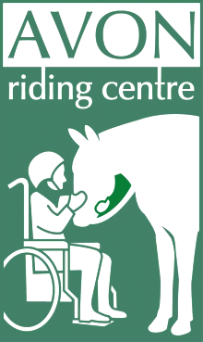
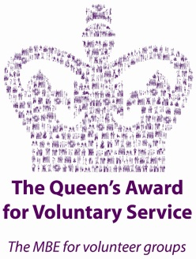
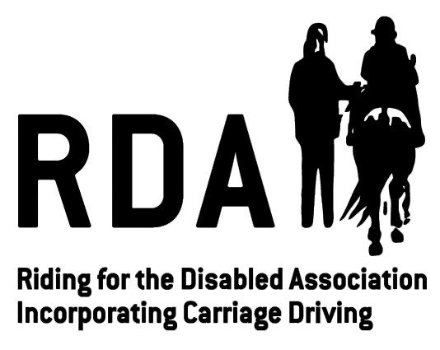
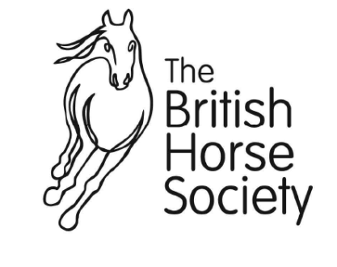
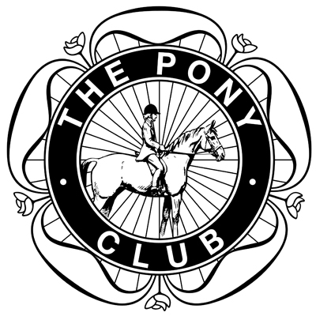
Avon Riding Centre for the Disabled Limited

Registered Charity
No: 281648

Company registered in England and Wales
No: 1534625

Patron:
Mary Prior MBE JP

President:
Marquess of Worcester

Vice Presidents:
Ginny Elliott MBE
Charlotte Leslie MP
Simon Laurens

Member of

An Approved BHS Riding School

A Pony Club Centre
Kings Weston Road, Henbury, Bristol BS10 7QT
Telephone: 0117 959 0266
Email: centreadmin@avonridingcentre.org.uk
Website: www.avonridingcentre.org.uk

Volunteering Application

Please complete all parts of the form, including postcodes, contact numbers and email addresses
for both yourself and your referees, and return the form to the address above.

1. Your Details
Full Name (inc. title)
Date of Birth
Address
Home Phone
Mobile
Email Address

2. Specific Information About You
The information you give in this section will be used to help us learn a little more about you,
understand your needs and ensure we are able to place you in a suitable volunteering role.

Experience volunteering or working with people with disabilities
Equine Experience
Other skills e.g. first aid, admin skills, maintenance skills etc.
We actively welcome volunteers from all walks of life. In order to help us ensure your safety whilst at the centre, please list any details of any health issues (medical conditions, allergies, specific needs, etc.) or disabilities you may have.

It is your responsibility to inform us should you develop any health issues whilst volunteering with us. We may request a doctor’s note to ensure you are fit to carry out your volunteering duties.

3. Emergency Contact Details
If you become a volunteer with us, it’s important we know who to contact in case you are injured or become ill whilst at the centre.

Full Name
Relationship to you
Phone

By ticking this box I confirm I have consent of the individual listed above to be contacted in the case of an emergency during the course of RDA activities.
4. I Would Like To Help With

Please tick as appropriate:

Helping in Lessons Fundraising/Events
Stable Work Estate/Land Maintenance
Administration Cafe

Other (please specify):…………………………………………………………………………………………………………………………………………
Please note: Any area of volunteering at the Centre does not include exercising or riding of the horses.

5. Your Availability
This helps us to know where we may best be able to accommodate you whilst also considering our needs. However, even if you can’t commit regularly due to shift work etc., we are still happy to hear from you!

If you are intending to volunteer as part of a Duke of Edinburgh award, please tick here.

 | Morning | Afternoon | Evening
Monday
Tuesday
Wednesday
Thursday
Friday
Saturday

6. References
All volunteers are required to provide two references in order for us to proceed with their application. The referees should be from a professional contact, such as an employer or teacher, where possible, and cannot be a family member. Both must have known you for a minimum of 2 years.
Full Name
Relationship to you
Address
Email
Phone

Full Name
Relationship to you
Address
Email
Phone

7. Declaration

- I consent to an enhanced disclosure check being made, will abide by the group’s policies and procedures and confirm that the information provided on the form is correct. I accept that failure to disclose information or subsequent failure to conform to the group’s Safeguarding Policies and Procedures may result in possible disciplinary action. I agree to pay £10 (not refundable) for this Disclosure and Barring Service check (DBS) at the time of my induction and training session, directly to Avon Riding Centre.

- Have you ever been convicted of a criminal offence or been the subject of a caution, a ‘bound over order’ or a ‘civil action’ involving physical or sexual abuse or violence?
No
Yes

If Yes, please give details:

- You are advised that under the provisions of the Rehabilitation of Offenders Act 1974 (exceptions) Order 1975 as amended by the Rehabilitation of Offenders Act 1974 (Amendment) 1986, you should declare all convictions, including ‘spent’ convictions.
Have you ever been subject to any disciplinary actions or sanctions relating to child abuse, sexual offences or violence?
No
Yes

If Yes, please give details:

- You are required to self-certify that you are not known to ANY Social Services as being an actual or potential risk to children, and that you have not been disqualified or prohibited from working with or fostering any children, or had any rights or powers in respect of any child vested in or assumed by a local authority, or had a child ordered to be removed from your care.

- As part of the checking procedures, you are advised that Avon Riding Centre reserves the right to make reference to the Local Authority Social Services Department and Police Records to verify information given on this form, when it is submitted to or at any time in the future.

- You recognise that certain aspects of volunteering, particularly arena and stable work, require a certain level of fitness and confirm you are capable of this. You accept that if the coach/stable management team feel that your physical fitness is impeding your ability to volunteer, or causing a hazard to others, you may be asked to volunteer in a less physically demanding environment.

By ticking this box I give consent to my photograph being taken during RDA activities for training and/or publicity use (including websites, social media, newsletters and marketing materials for the group and RDA UK). I give this consent acknowledging the photos will not be given to a third party without my explicit consent.

I agree to a mutual 1 month trial period of volunteering.

Signed:

Date:

