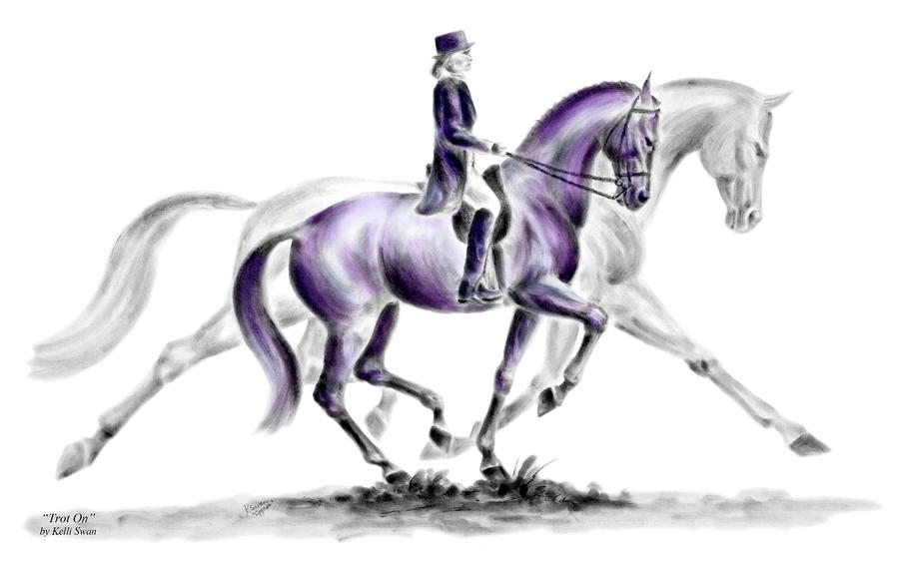
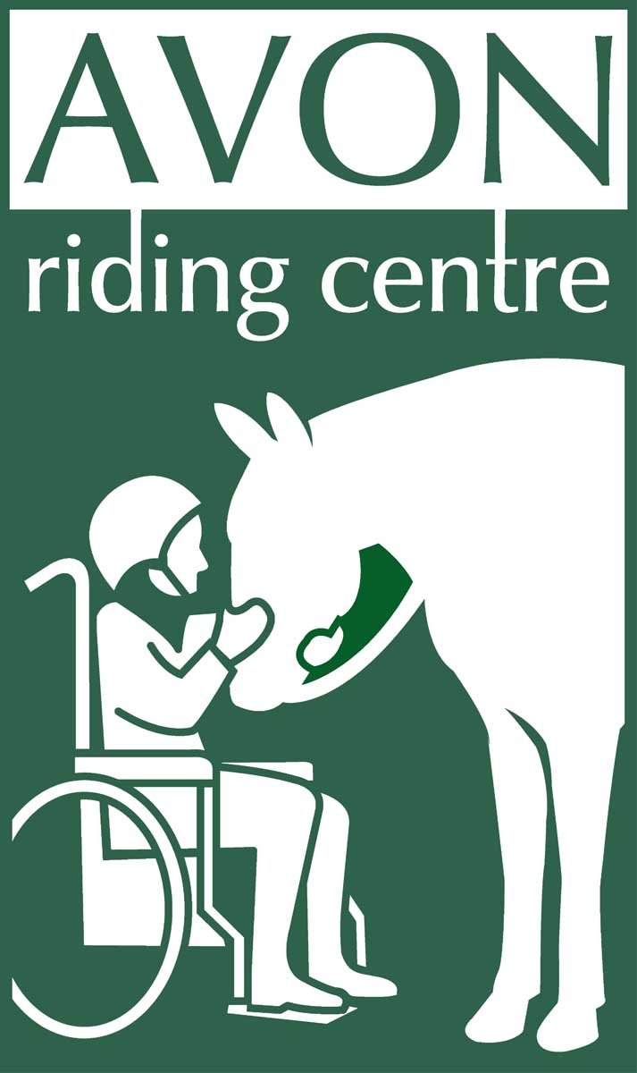

WINTER DRESSAGE
2015-2016

Avon Riding Centre
Kings Weston Road
Henbury Bristol BS10 7QT (opposite Blaise Castle)
Tel: 0117 959 0266
Email: ride@avonridingcentre.org.uk

Registered Charity No. 281648

Date | Class |  | Rider |  | Horse |  | Fee
 |  |  |  |  |  |  | £
 |  |  |  |  |  |  | £
 |  |  |  |  |  |  | £
 |  |  |  |  |  |  | £
Total Fee £
Enclosed
Riders Full Name Address

Tel No.

Email Address Postcode

Emergency contact:

Sunday 27th September
Class 1 – Intro A (2008)
Class 2 – Prelim 4 (2002)
Class 3 – Pick Your Own test from Prelim 14 (2006), Novice 27 (2007)
Sunday 25th October
Class 1 – ARC Test 2 (2012)
Class 2 – Prelim 12 (2005)
Class 3 – Pick Your Own Test from Prelim 14 (2006), Novice 34 (2009) or Elementary 44 (2002)
Sunday 6th December
Class 1 – Intro B (2009)
Class 2 – Prelim 7
Class 3 – Pick Your Own Test from Prelim 13 (2006), Novice 24 (2010)
Sunday 14th February
Class 1 – VHPRC Walk & Trot Test 1 (2007)
Class 2 – Prelim 13 (2006)
Class 3 – Pick Your Own Test from Prelim 18 (2002), Novice 28 (2008) or Elementary 42 (2008)
Sunday 13th March
Class 1 – ARC Test 3 (2014)
Class 2 – Prelim 14 (2006)
Class 3 – Pick Your Own Test from Prelim 1 (2006), Novice 30 (2006)
Sunday 10th April
Class 1 – Intro A (2008)
Class 2 – Prelim 12 (2005)
Class 3 – Pick Your Own from Prelim 7, Novice 27 (2007) or Elementary 49 (2009)

Trophies will be awarded to the riders who have accumulated the most points overall in each of the three Classes at the end of the Winter Series

Dressage Entries
Entries must be received with fee of £10 per class the Tuesday before each competition. Entries cannot be transferred or cancelled from this date. Post form with payment to Avon Riding Centre, Kings Weston Road, Henbury, Bristol, BS10 7QT. Cheque should be made payable to Avon Riding Centre for the Disabled.

Avon Riding Centre tests can be downloaded from www.avonridingcentre.org.uk .

For test times please see the website www.avonridingcentre.org.uk or call 0117 959 0266 on the Friday before each competition from 2pm.Phone number during shows is 07731 960751

Dressage Rules
To be run under British Dressage rules except same horse may be ridden by maximum of two riders.

Walk and Trot tests are designed for genuine new to dressage riders and inexperienced horses and ponies not previously placed 1st – 3rd at Prelim level or above. Others can enter at HC only.

Horses and ponies with affiliated points over Novice level HC only .Test callers allowed. Horses and ponies must be 4 years and over.

Trophies must be returned to Avon Riding Centre by 28th February each year.

Competitors must wear correct dress, footwear and hard hat. Hard hats must conform to current safety standards with a 3 point harness and chin straps must be fastened while mounted.

Competitors under 18 must be supervised by an adult. A qualified first aider will be in attendance.

All classes are ridden in indoor arena. Warm up in outdoor arena and must be done with consideration to others, with a maximum of 6 horses at a time and no sooner than 40 min before test time.

All horses are to be vaccinated to date and not be carrying any infectious diseases.

No mucking out of trailers/horse boxes on site. Droppings must be cleared from all areas. Dogs must be kept on leads and are not permitted inside buildings, except guide dogs.

Objections must be handed to an official in writing within 15 minutes of the end of a class with a £20 deposit. No refund of entry fees unless accompanied by a doctors or vets note.

Abusive behaviour towards any of the officials will not be tolerated and the offender will be asked to withdraw with no refund.

The organisers reserve the right to cancel classes, limit entries or amend rules at their discretion.

The Avon Riding Centre staff, volunteers, landowners or anyone acting on their behalf will not be held responsible for any loss/accident to persons, animals or property. Riders and spectators enter at their own risk.

