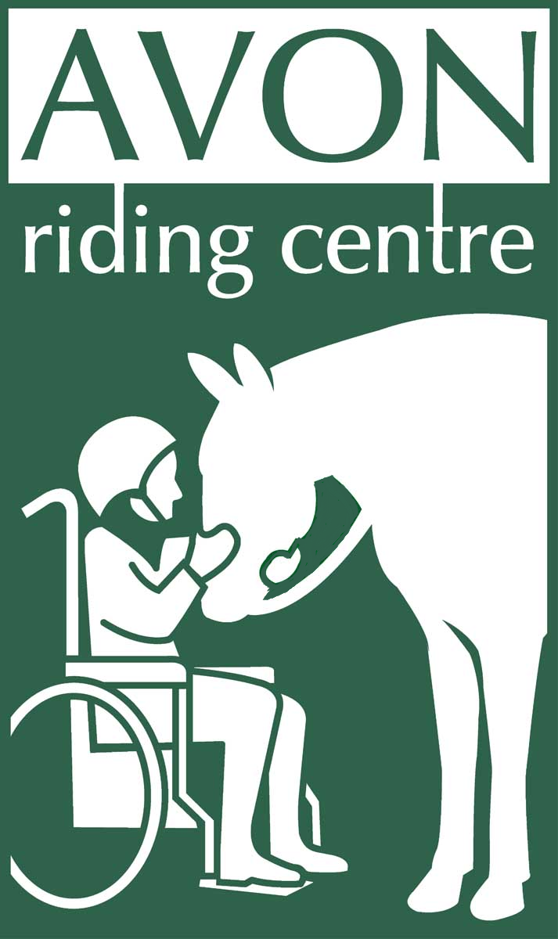

**Winter**

**Dressage**

**Series**

C:\Users\reception\AppData\Local\Microsoft\Windows\Temporary Internet Files\Content.IE5\VBII6P51\MC900363044[1].wmf

**October 5th 2014**

**November 2nd 2014**

**December 7th 2014**

**February 1st 2015**

**March 1st 2015**

**April 12th 2015**

**October 5th 2014**

**November 2nd 2014**

**December 7th 2014**

**February 1st 2015**

**March 1st 2015**

**April 12th 2015**

Avon Riding Centre

Kings Weston Road

Henbury Bristol BS10 7QT (opposite Blaise Castle)

**Tel:** 0117 959 0266

**Email:** [reception@avonridingcentre.org.uk](mailto:reception@avonridingcentre.org.uk)

Registered Charity No. 281648

**Avon Riding Centre Winter Open Unaffiliated Dressage Series 2014 / 2015**

**October 5th 2014**

**Class 1** Intro A (2008)

**Class 2** Prelim 1 (2006)

**Class 3** Pick your own Test from choice of:

Prelim 14 (2006) or Novice 24 (2010) – to be judged on percentages

**November 2nd 2014**

**Class 1** ARC Test 1b (2012)

**Class 2** Prelim 4 (2002)

**Class 3** Pick your own Test from choice of:

Prelim 12 (2005), Novice 27 (2007) or Elementary 44 (2002)

**December 7th 2014**

**Class 1** Intro B (2009)

**Class 2** Prelim 7 (2002)

**Class 3** Pick your own Test from choice of:

Prelim 18 (2002) or Novice 28 (2008)

**February 1st 2015**

**Class 1** ARC Test 2 (2012)

**Class 2** Prelim 13 (2006)

**Class 3** Pick your own Test from choice of:

Prelim 14 (2006), Novice 30 (2006) or Elementary 42 (2009)

**March 1st 2015**

**Class 1** ARC Test 3 (2014)

**Class 2** Prelim 1 (2006)

**Class 3** Pick your own Test from choice of:

Prelim 18 (2002) or Novice 34 (2009)

**April 12th 2015**

**Class 1** Intro A (2008)

**Class 2** Prelim 4 (2002)

**Class 3** Pick your own Test from choice of:

Prelim 12 (2005), Novice 28 (2008) or Elementary 49 (2008)

|  |  |  |  |  |  |  |  |
| --- | --- | --- | --- | --- | --- | --- | --- |
| **Date** | **Class** | | **Rider** | | **Horse** | | **Fee** |
|  |  | |  | |  | | **£** |
|  |  | |  | |  | | **£** |
|  |  | |  | |  | | **£** |
|  |  | |  | |  | | **£** |
|  | |  | |  | | **Total Fee £**  **Enclosed** | |
| **Riders Full Name Address**    **Tel No.**    **Email Address Postcode**  **Emergency contact:** | | | | | | | |

**Dressage Entries**

Entries must be received with fee of £10 per class the Tuesday before each competition. Entries cannot be transferred or cancelled from this date. Post form with payment to Avon Riding Centre, Kings Weston Road, Henbury, Bristol, BS10 7QT. Cheque should be made payable to Avon Riding Centre for the Disabled.

Avon Riding Centre tests can be downloaded from www.avonridingcentre.org.uk .

For test times please see the website www.avonridingcentre.org.uk or call 0117 959 0266 on the Friday before each competition from 2pm.Phone number during shows is 07731 960751

**Dressage Rules**

To be run under British Dressage rules except same horse may be ridden by maximum of two riders.

Walk and Trot tests are designed for genuine new to dressage riders and inexperienced horses and ponies not previously placed 1st – 3rd at Prelim level or above. Others can enter at HC only.

Horses and ponies with affiliated points over Novice level HC only .Test callers allowed. Horses and ponies must be 4 years and over.

Trophies must be returned to Avon Riding Centre by 28th February each year.

Competitors must wear correct dress, footwear and hard hat. Hard hats must conform to current safety standards with a 3 point harness and chin straps must be fastened while mounted.

Competitors under 18 must be supervised by an adult. A qualified first aider will be in attendance.

All classes are ridden in indoor arena. Warm up in outdoor arena and must be done with consideration to others, with a maximum of 6 horses at a time and no sooner than 40 min before test time.

All horses are to be vaccinated to date and not be carrying any infectious diseases.

No mucking out of trailers/horse boxes on site. Droppings must be cleared from all areas. Dogs must be kept on leads and are not permitted inside buildings, except guide dogs.

Objections must be handed to an official in writing within 15 minutes of the end of a class with a £20 deposit. No refund of entry fees unless accompanied by a doctors or vets note.

Abusive behaviour towards any of the officials will not be tolerated and the offender will be asked to withdraw with no refund.

The organisers reserve the right to cancel classes, limit entries or amend rules at their discretion.

The Avon Riding Centre staff, volunteers, landowners or anyone acting on their behalf will not be held responsible for any loss/accident to persons, animals or property. Riders and spectators enter at their own risk.