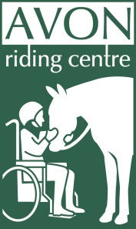
Avon Riding Centre for the Disabled Exit Survey

What is your main reason for leaving?

What can you say about the way your volunteering was organised?

How could the organisation have enabled you to have made better use of your time?

How can the organization gather and make better use of the views and experience of its volunteers?

What can the organization do to retain its volunteers?

Would you consider volunteering again for us if the situation were right?

Do you or are you going to Volunteer for another organisation? What, importantly, are they offering that we are not?

Any other comments?

